Name: Rana Ahmed SE-2

Week 2 Lab Report

Distributed Consistency and Consensus in the Cloud

1. Introduction
In this lab, I explored how distributed systems handle consistency, availability, and consensus. I used Redis to demonstrate replication and eventual consistency, and etcd to understand the Raft consensus algorithm and leader behavior.

2. Redis Replication and CAP Theorem

Experiment
I connected to two Redis nodes:
- redis-node1 (primary)
- redis-node2 (replica)
I wrote data to redis-node1 and then read it from redis-node2.

Observation
The data appeared on the replica, but sometimes there was a slight delay. This shows that replication is not immediate.

Network Partition Test
I stopped redis-node2 and then wrote new data to redis-node1.

Result
- The write operation still succeeded.
- The replica was unavailable and did not receive updates.

Explanation
This demonstrates eventual consistency, where updates propagate asynchronously.
It also shows the CAP theorem trade-off:
- The system favors Availability (A) and Partition tolerance (P)
- It sacrifices strong Consistency (C)

3. Raft Consensus using etcd

Experiment
I used etcd to store and retrieve key-value data.

Commands used:
- put key-value pair
- get key
- check endpoint status

Observation
- The system successfully stored and retrieved data.
- The node acted as a leader (since only one node was used).

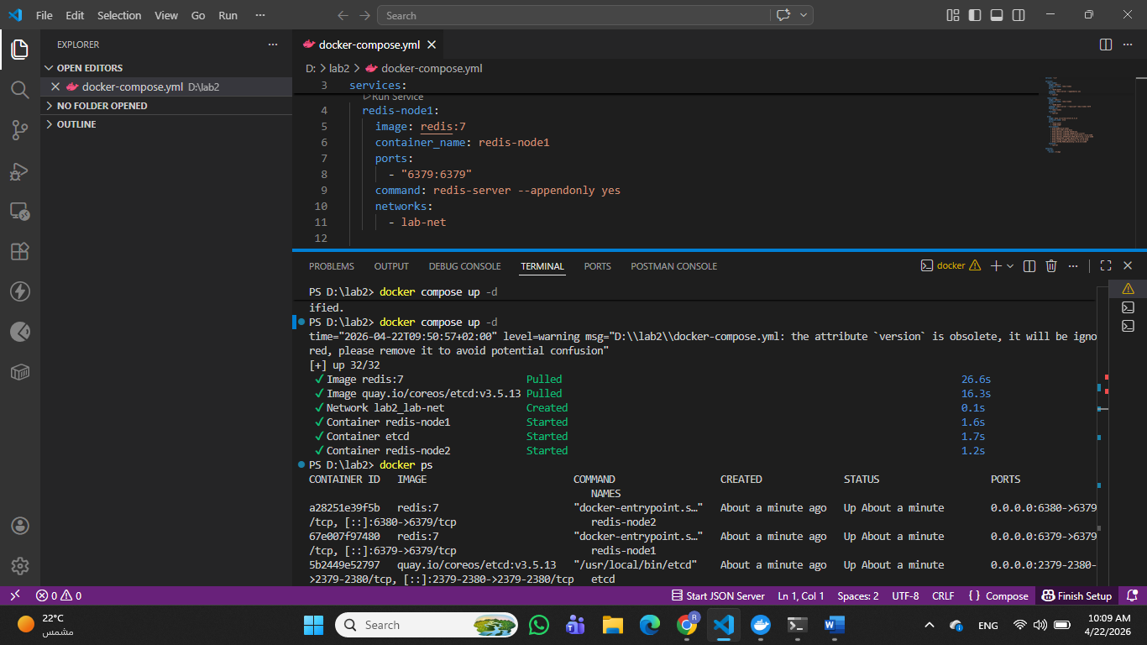

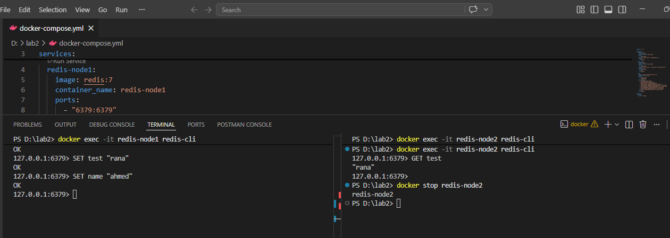
Here 1. Redis — Write on Node 1
2. Redis — Read from Node 2 and this proves replication
3. Redis — After Stopping Node 2
Then in node1: SET name “ahmed” proves availability during partition
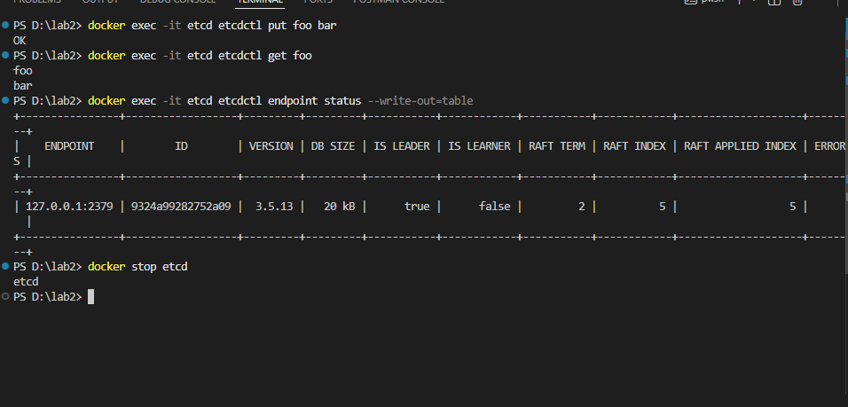
- etcd — Put Command
2. etcd — Get Command
3. etcd — Endpoint Status

